So we are given 2 data sets for this assignment, global data and data nation.

First we will be working on data nation

**1) Death Rate in colors**

Drag and drop death rate and city to column and rows respct.

Drag death rate measure to colors in marks.

Sort city name acc to field death rate in desc.

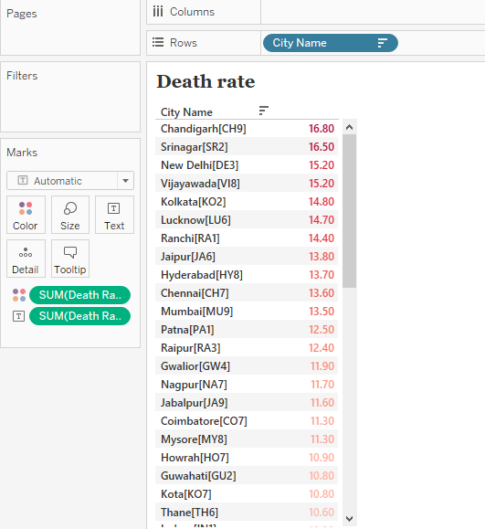

**2) DR and population**

Drag and drop city and population current to column and rows respct.

Drag death rate measure to color in marks card.

Sort city name acc to field population rate in desc.

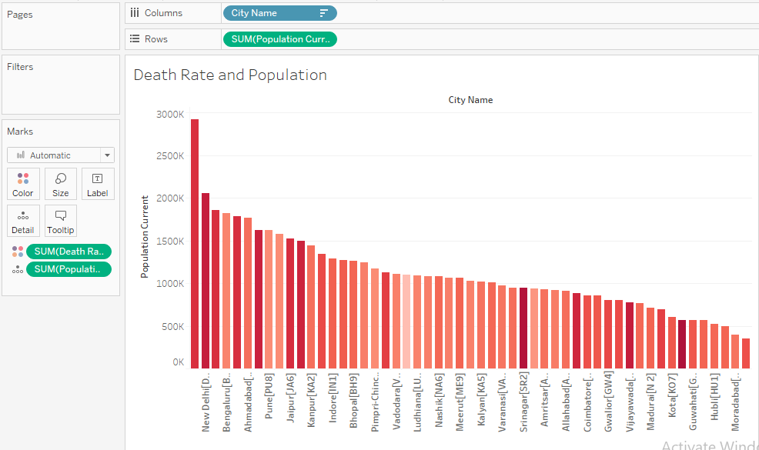

The Darker the color, the more the death rate.

**3) Prominent Cities with Large populations**

Drag and drop city and population current to column and rows respct.

Drag city name into the filters and choose top. filter the data by top 10.

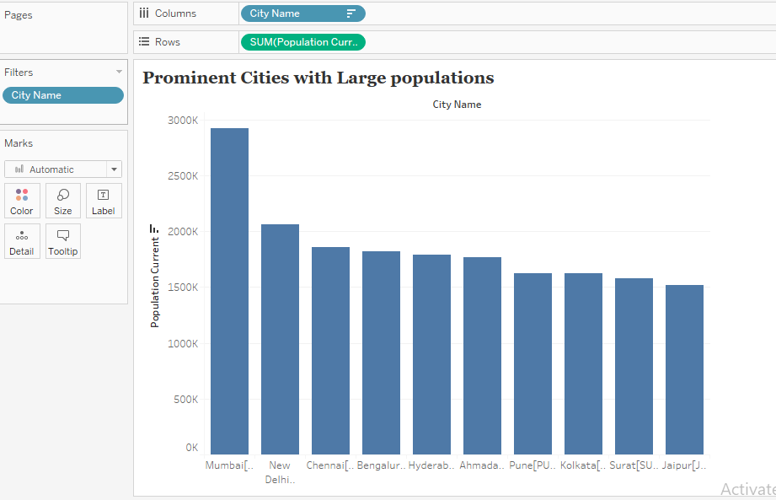

Top 10 most populous cities of india

**4) Death rate of cities**

Convert city into geographical data.

Drag city into visualization Area.

Drag death rate into color field in marks card.

Cities with more death rates are highlighted darkly and has larger circle radius.

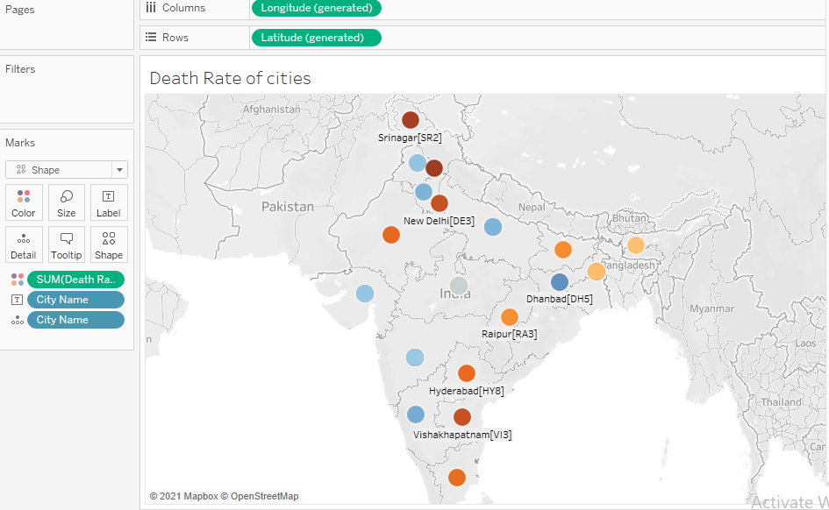

Chandigarh city leads in terms of death rate.

**5) Group coastal cities**

Using Lasso select the coastal cities

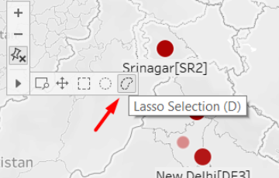

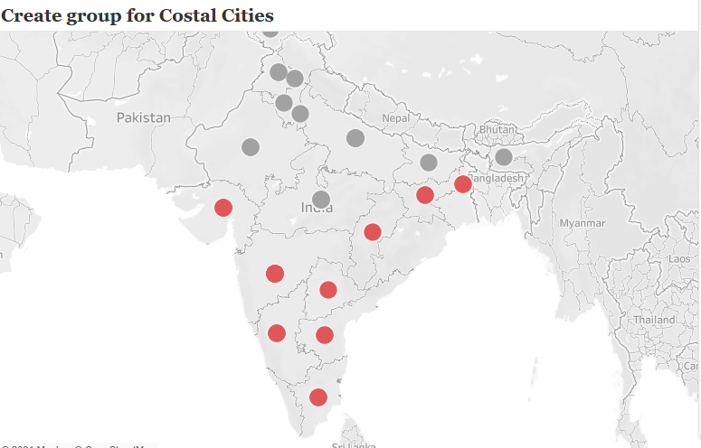

**6) Create a filter on Coastal Cities**

Drag and drop the coastal cities group onto filters card then select the box.

After selecting the box only coastal cities will be indicated on the map.

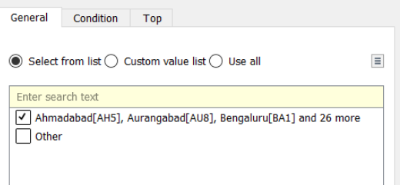

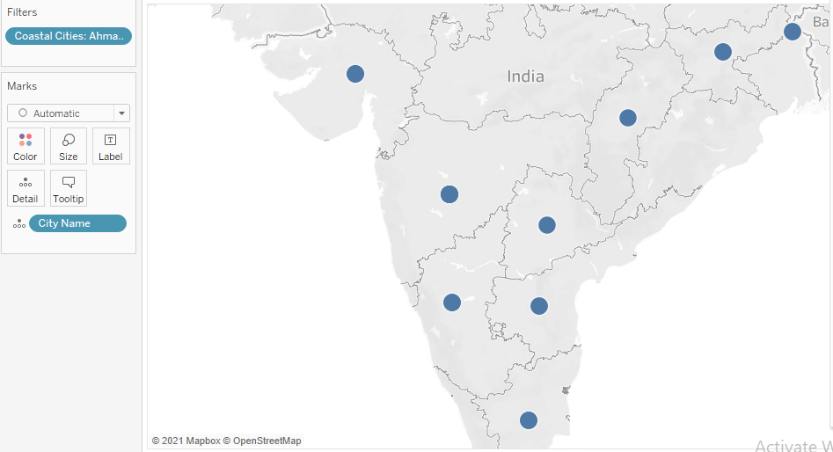

**7) Change Map Layers**

Go to Map and select Map layers the change them.

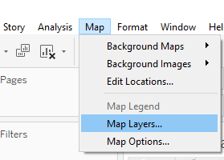

Change the map layers however you want to.

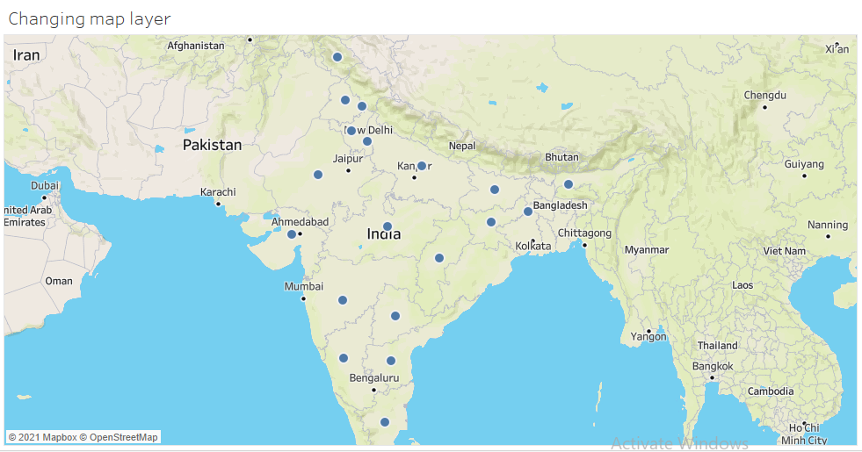

Outdoor style map

**8) Use the Global Data**

Select the new data source option. Then connect the excel file.

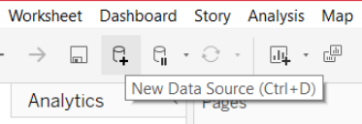

Now connect to Microsoft excel and select the "global data" file. Sel

Select the data from data section to use it.

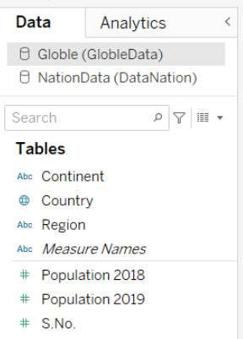

9) Create Hierarchy

Right click on "Continent" dimension and click on "Geographical Role" then click on

"Create from" then click on "Country" option.

Right click on "Region" dimension and click on "Geographical Role" then click on

Create from" then click on "Continent" option.

Rename the hierarchy as "Location".

Sort the hierarchy as shown below:

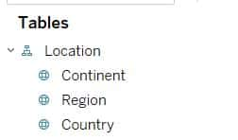

**Continent with diff Population**

We have used Side-by-side  circle visualization here

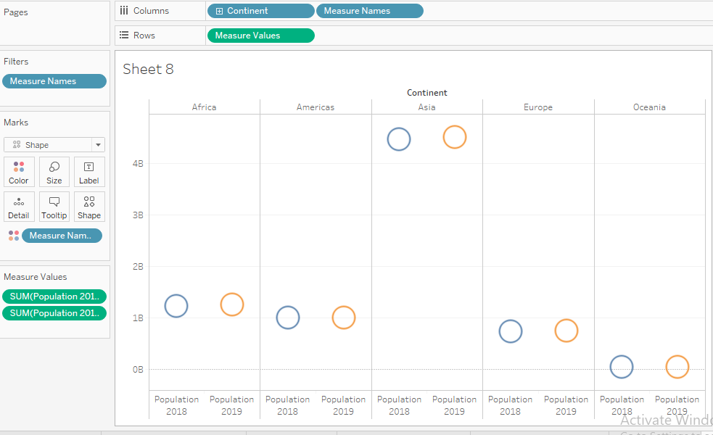

Population in continents for years 2018 and 2019

**Determine the Inc/Dec in Population**

Drag and drop country to visualization area.

Create a calculated field and name it change in population.

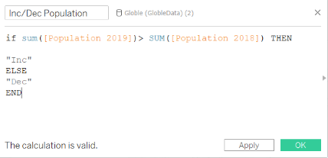

Drag and drop change in Population measure on to Shape under Marks card.

Assign Down Arrow to Dec and UP Arrow to Inc. Click on OK.

step 5) Drag and drop "Inc/Dec in Population" measure on to Color under Marks card and you will see the visualization as below.

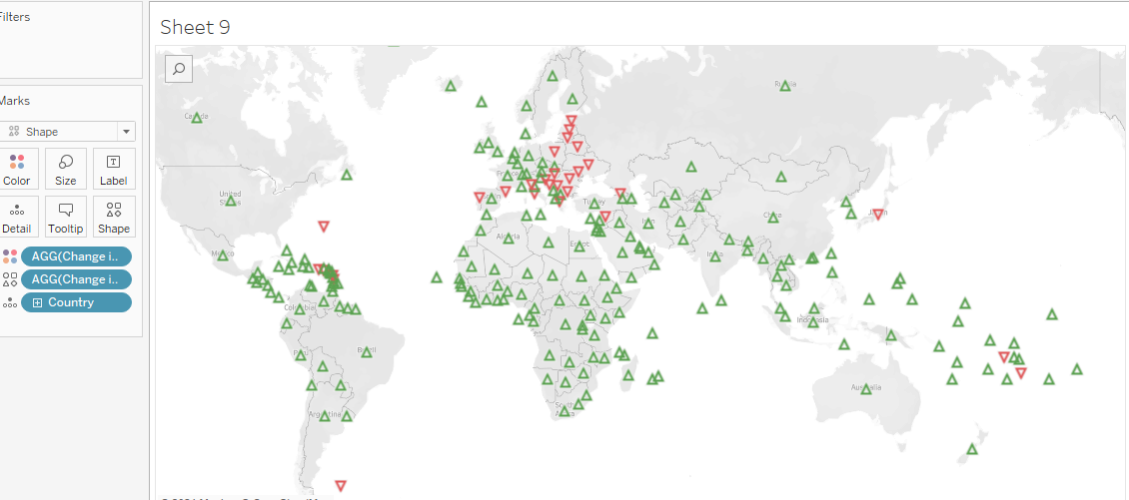

Inc/Dec in world population in year 2019